Simulation of Cosmic Muons in the ATLAS Tile Calorimeter

Seth Zenz⁽¹⁾

⁽¹⁾ University of Chicago, Chicago, USA

Abstract

This note describes a simulation of cosmic muons passing near the origin of the ATLAS detector, and discusses whether they can be detected in the Tile Calorimeter sufficiently frequently to serve a useful purpose during the commissioning of the detector. The simulation accounts for the angular dependence of the overburden and the effects of the ATLAS cavern’s access shafts. The energy and angular distribution of simulated events is consistent with expectations; in particular, there is a significant peak in events at angles corresponding to a reduction in overburden due to the large access shaft. The predicted event rate of 0.37 Hz is consistent with previous calculations, and is significant enough to be useful to the commissioning of the Tile Calorimeter and the detector as a whole.
1 Introduction

A key step in the commissioning of the ATLAS detector will be the use of cosmic rays to evaluate the performance of various systems. This will begin in the Tile Calorimeter shortly after it is installed in 2004, and will occur detector-wide from the latter part of 2006 through March 2007. There are two general questions to be asked about this phase of commissioning: what information can be learned from the detection of cosmic muons, and what means might be used to provide a trigger for the relatively rare events in which muons pass through all parts of the detector. In considering the role of the Tile Calorimeter, the latter question is of particular interest, as it is possible to use TileCal itself to trigger on muons passing near the origin of the detector.
An initial calculation by J. Pilcher [1], using measurements summarized by the Particle Data Group and some simple assumptions about the rock above the ATLAS cavern, indicated that the expected rate of useful events was roughly 0.025 Hz, or about 90 events per hour. This would indeed be a useful trigger rate. However, this calculation neglected the zenith angle dependence of the overburden, as well as the effects of the access shafts above the cavern. In order to account for such effects, and confirm and refine these results, a full simulation of muons traversing both the overburden and the detector itself is required. This note describes a study based on such a simulation, using GEANT 3 and ATLAS reconstruction software to determine more accurately the rate of muons that the Tile Calorimeter could detect passing near to the origin of the detector.

2 Initial Flux

The input data for the study comes from a GEANT simulation, produced by Rob McPherson, of cosmic muons passing through the ground above the ATLAS cavern and the detector itself [2]. These simulations use one of two possible models for surface muon flux. The first was the Particle Data Group approximation formula (“PDG flux”), while the second was based on a fit to measured fluxes by Alois Putzer for simulation of the ALEPH detector (“ALEPH flux”) [3]. The latter is understood to be more accurate, and absolute rates are based on these data unless otherwise specified. The PDG flux, which neglects muon decay-in-flight and therefore gives too high a rate for muons of energy below about 100 GeV, are useful primarily for increased statistics in kinematic plots. A total of 190 ALEPH flux files, each simulating 9.2 seconds of real time, were available for a total time of 1748 seconds, while the 190 PDG data files each covered 4.42 seconds for a total of 839.8 seconds.

3 Possible Cuts

These simulations were used as input for the ATLAS Athena reconstruction software. This was used to process signals from the tile calorimeter in response to muon energy deposits, providing the frequency and characteristics of events satisfying various trigger requirements. The basic definition for a muon being of interest is that it passes roughly through the origin of the detector, so the basic trigger requirement is that that there be “back-to-back” towers (i.e., towers exactly opposite each other, with azimuthal angle φ values differing by π and opposite signs of the psuedorapidity η) with substantial energy deposits. Only the barrel is used for this study, requiring |η|<0.8. Rates were computed for varying tower sizes, allowing acceptance of hits within that were back-to-back within a Δη x Δφ area of 0.1x0.1, 0.2x0.2, or 0.4x0.4, and for varying values of the minimum energy in each of the back-to-back towers. These rates are discussed in section 7. Plots of tower energy and angular dependence throughout this note use a 0.1x0.1 area and an energy requirement of at least 1.5 GeV in each of the two back-to-back cells.

4 Response of Calorimeter to Sample Events

An example of an ideal event, in which the muon passes very near to the origin of the detector and deposits all its energy in one calorimeter tower on each side of the barrel, is shown graphically in Figure 1. Substantial energy deposits appear in the A, BC, and D layers of both towers. However, the data have a slight complication: because the outermost D layer has a size of 0.2x0.1, the energy deposited in the D cell is automatically split evenly between the tower through which the muon actually passed and the adjacent tower. Thus, because the D cell deposit accounts for roughly 20% of the total muon energy deposit in one calorimeter wedge, the total energy in the back-to-back towers is only 90% of the actual energy deposited by the muon. There are furthermore two additional
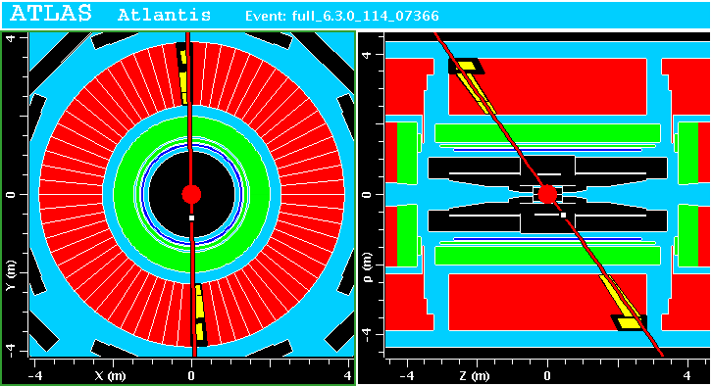
reconstructed towers produced from the remaining 10% of the energy in the adjacent D cell. This effect is easy to recognize and account for, and in any case can be safely ignored in determining trigger rates because almost all muons of interest should deposit significantly more than the 1.5 GeV cutoff energy in each side of the tile calorimeter. These effects can be seen in figure 2.
Figure 1: Display produced with ATLAS Atlantis software of ideal event with all energy deposited in one calorimeter tower. Note the double width in η of the outermost-layer D cells; this leads to 10% of the energy deposited on each side of the barrel being recorder in the adjacent towers.
More complicated events, in which the muon passes slightly further from the origin or along the boundary between towers, and thereby deposits energy in several layers of multiple towers, also occur (Figure 3). In rare cases, the muon can even be scattered somewhere within the detector. However, in all but the most extraordinary events, requiring back-to-back 1.5 GeV towers will give a muon that passes quite close to the origin of the detector.

5 Distribution of Tower Energies
Figure 2: Energies of all towers for the 111 simulated events using both the ALEPH and the PDG flux. Event selection requires at least 1.5 GeV in two back-to-back towers.

The distribution of the energies of all towers in events satisfying the cuts is easy to interpret in light of these effects. The plot of this distribution, which combines both the ALEPH and PDG flux for a better sample (Figure 2), has two major features. The first feature, the large peak at low energy trailing off at around 1 GeV, can be interpreted as partial towers, either produced by the double width of the D cell in eta or by the muon crossing tower boundaries. Note that these effects are quite common, as can be observed from the fact that both data sets give an average of about 5 towers per event with at least 200 MeV. The second distribution beginning at 1.5 GeV represents the towers that actually satisfied the back-to-back and minimum energy requirements. It peaks in the expected region of around 2.5 GeV and extends to higher energies because of the tail of the landau distribution and the additional path length for larger |η|.
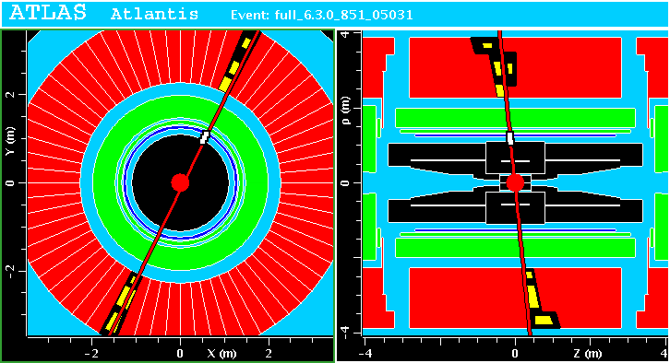
Figure 3: Display produced with ATLAS Atlantis software of a more complicated event, in which the muon passes along the boundary between towers.
6 Distribution of Towers in Eta and Phi
The distribution of towers as a function of the azimuthal angle φ appears in Figure 4. It has roughly the expected shape (symmetrical around the vertical and proportional to cos²θ), although the details of the plot are irregular even with the data from the ALEPH and PDG flux combined, due to low statistics.
The distribution in η shown in Fig. 5 has a remarkable feature. Instead of peaking around zero, the most frequently occurring η values are between –0.1 and –0.4. A schematic of the ATLAS cavern (Figure 6) reveals the reason for this. This region in η corresponds to angles for which a significant amount of the muon’s flight passes through the large access shaft rather than through the ground, allowing for more lower-energy muons to penetrate the surface and reach the tile calorimeter with sufficient energy. This explanation is further confirmed by a plot of η vs. ϕ (Figure 7), which reveals that a significant concentration of events at these η values occurs at ϕ values near the vertical.
Figure 4: Histogram of φ distribution for the tower in the top half of the calorimeter that satisfies back-to-back and energy requirements. Note that in this plot φ=0 corresponds to the vertical.
No similar effect is seen for positive η, for the other shaft is both smaller and centered further from the origin of the detector. The region for which the smaller shaft produces at least a 50% reduction in overburden goes from about -0.05 to -0.4 in η, or about 19 degrees, for the larger shaft, and from about 0.25 to 0.4 in η, or about 8 degrees, for the smaller shaft. Thus the total solid angle of the region of reduced overburden for the larger shaft is over four times greater than that for the smaller shaft, greatly reducing the expected number of additional events. Furthermore, the region for the larger shaft corresponds to much more nearly vertical angles, with a corresponding higher rate of muon flux.

-0.1
-0.2
-0.3
-0.4
0.4
0.3
0.2
0.1
0
Figure 6: Schematic of the ATLAS cavern, courtesy of Rob McPherson, with lines of constant η values added. The green box represents the cavern itself, while the blue rectangles are the access shafts. Note that the area with –0.4<η<-0.1 has the particles spending the greatest amount of time in the large shaft before passing through the tile calorimeter, corresponding to the peak in event rate simulated for those values.
Figure 5: Histogram of η distribution for the tower in the top half of the calorimeter that satisfies the back-to-back energy requirements.
7 Estimated Trigger Rate

The rates for different total tower sizes and energy cutoff values, for ALEPH flux data, are given in Table 1 and plotted in Figure 8. The 0.1x0.1 tower size is of the most interest, for two reasons. First, it insures the closest proximity of the muon to the center of the detector. Second, the electronic noise in the 0.1x0.1 case is expected to be about 400 MeV and scales with the square root of the number of elements. Thus the noise for the 0.2x0.2 tower size would be 800 MeV, while in the 0.4x0.4 case it would be 1.6 GeV—these compare to expected tower energy of around 2.5 GeV, giving prohibitively low signal-to-noise ratios. The 0.1x0.1 case is plotted separately in Figure 9.
An energy cutoff of 1.5 GeV, giving a signal-to-noise ratio of 3.75 for the expected 400 MeV of noise per 0.1x0.1 tower, is deemed the best candidate for actual trigger requirements. In this case the ALEPH flux data contain 65 events satisfying the trigger requirements in the 1748-second length of the simulation, giving a rate of 0.037 ± 0.005 Hz (or ~130 per hour), comparable with the initial estimate of 0.025 Hz. The PDG flux data are comparable, with 46 events in 839.8 seconds, for a rate of 0.055 ± 0.008 Hz.
Figure 7: φ vs. η distribution for the tower in the top half of the calorimeter that satisfies the back-to-back and energy requirements.

8 Summary and Conclusions

The rate determined in this study is of the same order of magnitude as initial estimates, and confirms that muons can be expected (using reasonable and feasible trigger requirements) to be detected passing near the origin of the detector at a useful rate, on the order of 100 events per hour. Although the available event sample is small, the distribution in η and ϕ conforms roughly to expectations. It clearly shows the effect of the large access shaft as a substantial rate increase between η of –0.4 and –0.1, which largely accounts for the 50% increase in event rate from initial calculations. The Tile Calorimeter can indeed provide the trigger for interesting events to other parts of the detector during the cosmic muon phase of commissioning.

Energy Cutoff (GeV) | 0.1x0.1 | 0.2x0.2 | 0.4x0.4
0.2 | 0.199 | 1.454 | 5.311
0.25 | 0.189 | 1.275 | 4.947
0.3 | 0.165 | 1.073 | 4.477
0.35 | 0.142 | 0.949 | 4.176
0.4 | 0.132 | 0.876 | 3.967
0.45 | 0.124 | 0.830 | 3.791
0.5 | 0.116 | 0.795 | 3.672
0.55 | 0.110 | 0.760 | 3.559
0.6 | 0.102 | 0.735 | 3.462
0.65 | 0.095 | 0.712 | 3.364
0.7 | 0.092 | 0.689 | 3.270
0.75 | 0.085 | 0.668 | 3.180
0.8 | 0.080 | 0.640 | 3.084
0.85 | 0.073 | 0.623 | 2.979
0.9 | 0.070 | 0.598 | 2.866
0.95 | 0.066 | 0.579 | 2.749
1 | 0.062 | 0.555 | 2.624
1.05 | 0.059 | 0.541 | 2.499
1.1 | 0.054 | 0.525 | 2.370
1.15 | 0.050 | 0.501 | 2.236
1.2 | 0.049 | 0.482 | 2.105
1.25 | 0.047 | 0.457 | 1.961
1.3 | 0.045 | 0.435 | 1.829
1.35 | 0.044 | 0.416 | 1.699
1.4 | 0.043 | 0.394 | 1.562
1.45 | 0.039 | 0.379 | 1.450
1.5 | 0.037 | 0.362 | 1.334
1.55 | 0.037 | 0.343 | 1.228
1.6 | 0.036 | 0.323 | 1.118
1.65 | 0.034 | 0.307 | 1.007
1.7 | 0.031 | 0.285 | 0.916
1.75 | 0.031 | 0.266 | 0.828
1.8 | 0.030 | 0.251 | 0.745
1.85 | 0.027 | 0.232 | 0.662
1.9 | 0.026 | 0.212 | 0.585
1.95 | 0.023 | 0.200 | 0.527
2 | 0.022 | 0.186 | 0.466
Table 1: Rate of events (in Hz) satisfying back-to-back trigger conditions as a function of the minimum energy of each tower and the size of the towers.
References

[1] http://hep.uchicago.edu/cosmics/Commissioning_with_Muons.ppt

[2] http://rmcphers.home.cern.ch/rmcphers/atlas/cosmics/

[3] http://rmcphers.home.cern.ch/rmcphers/atlas/cosmics/CosmicAthens4.pdf

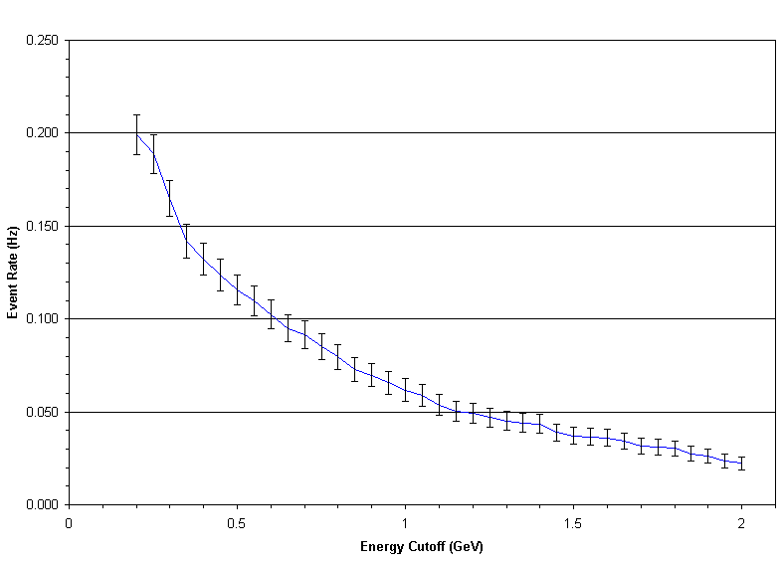
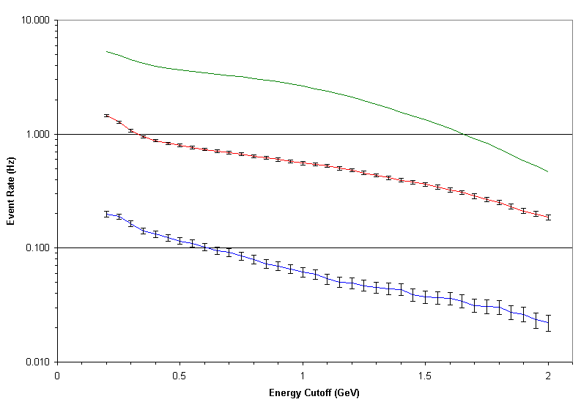
Figure 8: Log plot of the rate of events satisfying back-to-back trigger conditions as a function of the minimum energy of each tower, for tower sizes of 0.1x0.1, 0.2x0.2, and 0.4x0.4. Note that the error bars for 0.4x0.4 are too small to be displayed on this plot.

Figure 9: Rate of events satisfying back-to-back trigger conditions as a function of the minimum energy of each tower for tower size of 0.1x0.1.

0.4x0.4
0.2x0.2
0.1x0.1

