Picosecond Time-of-Flight Measurement for Colliders Using Cherenkov Light
Timothy Credo, Henry Frisch, Harold Sanders, Robert Schroll, and Fukun Tang

Abstract--We propose to measure the velocity of particles produced at a hadron or lepton collider by measuring the time-of-flight in a finely segmented cylindrical geometry, in which the particles product Cherenkov light while traversing the window of one element in an array of large-area (e.g. 5 cm x 5 cm) multi-channel-plate photomultipliers (MCP’s). There has been a substantial improvement in the time resolution of MCP’s, which now have achieved a 10-psec transit-time spread (FWHM) for a single photon. We have simulated the Cherenkov emission and MCP response spectra for several commercially available MCP’s, and find that a TOF resolution on the order of 1 psec should be attainable. This would allow $π/K$ separation at $1σ$ up to a transverse momentum of $\text{25 GeV/}c$ in a detector such as CDF at the Fermilab Tevatron. It may also be possible to associate a photon with its production vertex by conversion directly in front of the MCP. The system we are considering requires a custom large-area MCP design with an anode consisting of impedance-matched segments, directly coupled to a circuit capable of psec resolution. Possible problems we know of so far are showering in the magnet coil that is in front of the system and stray magnetic field outside the coil. One last consideration is the cost, which will be comparable to other major detector subsystems.

INTRODUCTION
The experimental probing of most of the most fundamental problems in particle physics relies on the identification of `flavor', the quantum numbers that differentiate the 6 kinds of quarks and the three generations of leptons. For example, the Higgs boson is expected to decay primarily to b-quarks, as they are massive. The top quark, which is strikingly more massive than the other quarks, decays into a W boson and a b quark; the W itself decays equally to a pair of light quarks, the up and down quark, and to somewhat heavier pair, the strange and charm quarks. The identification of b-quarks is a major tool in the study of the properties of the top quark.
The quarks themselves are not stable, and essentially instantaneously decay to states of integer electric charge and zero net color (the charge of the strong interaction). These states consist of a number of particles, which can include pions, kaons, protons, etc., and also the leptons (electron, muon, tau, and their neutrinos). By measuring the final particles one can reconstruct the parent process, and hence investigate the deeper questions of mass and flavor.
Identifying the secondary particles is therefore one of the goals of particle detectors, large devices built around the sites where the beams intersect. Typically built in and around a large solenoidal magnet, these detectors consist of various devices to measure the time, position, direction, and energy of the secondary particles. The large magnetic field (typically on the order of 1-2 Tesla) bends the tracks of charged particles, giving a measure of their momentum.
The charged hadrons $π$, $K$, and $p$, the predominant types produced in collisions, have very similar interaction characteristics. For momenta above a few GeV most particle detectors measure only the 3-momentum, and cannot distinguish one hadron from another. The mass can be measured by combining a velocity measurement with the momentum measurement. This velocity measurement is the goal of time-of-flight (TOF) systems. Since the secondary particles are typically moving at nearly the speed of light, the time differences between different particles with the same momentum are very small. Figure 1 shows the difference in the time it takes the charged hadrons to travel 1.5 m, as a function of momentum. More accurate mass measurements may also allow the identification of stable heavy exotic particles which would otherwise be mis-identified as known particles, and could also allow the detection of heavy unstable particles from the identification of delayed secondaries if then lifetimes are long enough [1].
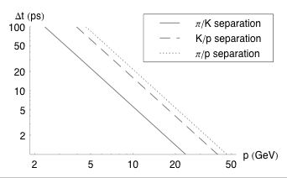
Fig. 1. The separations of pions, kaons, and protons, the difference in the time it takes two different particles with the same momentum to travel 1.5 m, as a function of momentum. Large time-of-flight detector systems have a time resolution on the order of 100 ps [2]-[4].

Proposed Cylindrical TOF System
We propose developing a TOF system in which the particles travel directly through the photodetector itself, generating Cherenkov light which is detected after traversing only a short path length (no bounces). This requires that the collision vertex by surrounded by detectors in a cylindrical array as shown in Figure 2. Particles would be tracked by the tracking systems inside the solenoid, and extrapolated to the TOF system to give a precise location of where the particle struck. The particle traversing the window of the photodetector, which in the present study would be a custom photomultiplier microchannel-plate (MCP-PMT), produces Cherenkov light, which is then converted and amplified by the MCP. Such a setup eliminates the scintillation process, the long light paths with their consequent variation, and the jitter of conventional photomultipliers, which limit the time resolution of traditional TOF systems.
We need a TOF resolution on the order of 1 ps to separate pions from kaons up to at least 20 GeV in a detector the size of CDF (radius approximately 1.5 meters). One candidate photodetector for this purpose is a micro-channel plate photomultiplier tube. Because of the small channel diameter and compactness of the device, which is only several millimeters thick, electron path lengths through the micro-channel plate cannot vary much; small MCP’s are now available with measured transit time spreads (TTS) of 10 psec (FWHM) [5].
Fig. 2. A schematic showing the placement of photodetectors around a detector solenoid coil. The detectors may also be placed just inside of the coil.

In order to minimize the path length uncertainty in detecting a signal on the anode, the proposed design requires a highly segmented multianode in which signals are routed from each pad to a small number of collection points through transmission lines of equal transit time, each of which then would be digitized.
As a possible further development, a TOF system with a 1 ps time resolution might be used to associate photons with individual collision vertices at the Tevatron and LHC, where more than one collision occurs in a given beam crossing. With the addition of a converter (e.g. a thin sheet of lead), and the ability to measure spatial resolution at the face of the MCP with a resolution of 100 microns or so, When the two beams collide, there may be several individual particle collisions occurring at different times and different positions along the beams, each of which may produce photons and other particles. Being able to measure the arrival time of the photons to 1 ps would give sub-millimeter resolution on their path length, helping one to distinguish which collision vertex created which photon.
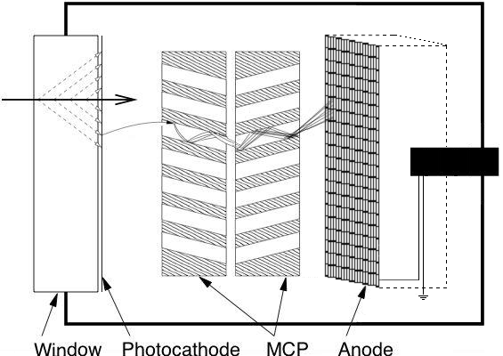

Fig. 3. A schematic of the proposed detection scheme. A relativistic particle produces Cherenkov radiation in the window of a PMT-MCP. This radiation is converted into electrons by a photocathode. The electrons produce a shower in the micro- channel plates, and the shower is deposited on the anode. After transmission through an impedance matched segment, the signal is detected from a central collector, and conveyed to an on-board chip in which it is digitized.

Cherenkov Radiation
Cherenkov radiation is produced by a charged particle in a medium when the velocity of the particle exceeds the velocity of light in that medium [6],[7]. Since the velocity of light in a medium is $c/n$, where n is the index of refraction, Cherenkov light will be produced whenever $v>c/n$, or using $β≡v/c$, $βn>1$. This radiation is produced essentially instantaneously. In the limit of an infinite radiating medium, it forms a coherent wavefront in the shape of a cone. A little geometry shows that the Cherenkov cone must have an opening half angle of $π/2−θ_{C}$, where
$\text{cos}θ_{C}=\frac{1}{βn}$ . (1)
Since we will be studying cases in which the thickness of the radiator is on the order of 1000 times the wavelength of the radiation in question, the infinite radiator approximation is valid.
Cherenkov radiation is ‘blue’; that is, there is more energy in the shorter wavelengths. The number of photons radiated per wavelength per distance is
$\frac{∂^{2}N}{∂x∂λ}=\frac{2{πZ}^{2}α}{λ^{2}}\left(1−\frac{1}{β^{2}n(λ)^{2}}\right)$ (2)
where Z is the charge of the particle (in multiples of e) and $α$ is the fine structure constant [2],[3]. As a rule of thumb, the number of visible photons radiated per centimeter is $∂N/∂x=\text{400}{\text{sin}}^{2}θ_{C}$ [8].

Detection
Three main factors will affect the time resolution of the detector. The first is the spread in the arrival of the Cherenkov radiation to the photocathode. When the charged particle reaches the back edge of the radiator, the radiation produced at the end of its path will also be at the back edge of the radiator. Working out the geometry, we can show that a photon emitted a distance x from the back of the radiator will still have to cover a distance $d=x(βn−1/{βn})$ to reach the end of the radiator when the charged particle exits the radiator. Thus, in a radiator of thickness T, the first photons emitted will arrive
$Δt=\frac{T}{βc}\left(β^{2}n^{2}−1\right)$ (3)
after the last photons emitted. Since the photons are emitted uniformly along the path of the charged particle, they will arrive uniformly, neglecting absorption, during the interval $Δt$.
Another factor in the time resolution of the detector is the transit time spread (TTS), or jitter, associated with MCP itself. The time it takes from the creation of a photo-electron to the production of a signal will vary slightly from trial to trial. Some of this variation comes from the differences in path length of the first photo-electron, but most arises from uncertainties inherent in the MCP itself. The best detectors currently on the market have transit time spreads of tens of picoseconds. Burle Industries has developed a 2 $μ$m pore MCP that has achieved a 10 ps TTS [5].
The final factor is the path length variation as the electrical signal travels through the anode to a central collector. To minimize the effect on time resolution, we propose a multianode design in which a 2 in x 2 in anode is subdivided into 400 pads, with a separate readout for each 100. The signals from each of the 100 pads per quadrant are routed to a central collector through transmission lines of equal length and time delay. While the RMS time spread for a 2 in x 2 in anode is as severe as 48 ps (not including the effect of reflections, which will be severe), the multianode layout shrinks path length uncertainty to 1.2 ps.

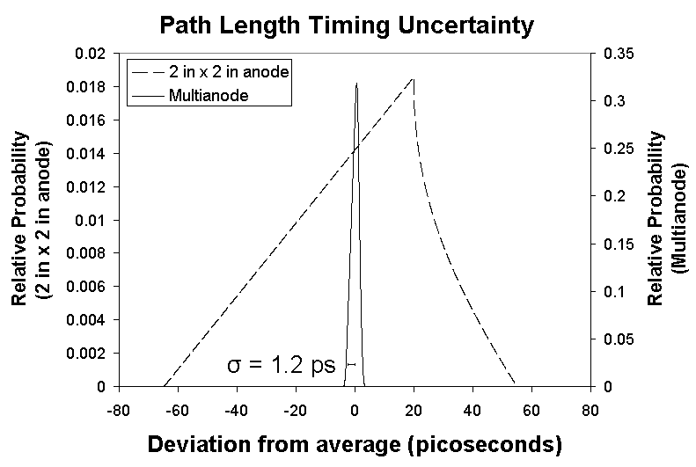

Fig. 4. The timing distribution resulting from path length differences on the anode. On a 2 in x 2 in anode, the RMS is as severe as 48 ps, but a multianode design improves the RMS to 1.2 ps.

Simulation
In order to fully understand the properties of our system, we developed a Monte Carlo algorithm to simulate the emission and detection of Cherenkov radiation. Although a custom design would optimize parameters like window material and thickness, for now we use typical values cited in a Hamamatsu brochure [9]. This brochure also includes plots of quantum efficiency (the probability of electron emission for each photon that reaches the photocathode) of several detectors versus wavelength.
The algorithm works by splitting the radiator into a grid in $x$, the distance into the radiator, and $λ$, the wavelength. At each point in the grid$∂^{2}N/∂x∂λ$ was calculated. After multiplying by $∂x∂λ$, this is taken to be the probability of photon emission from that location. After randomly deciding if a photon is produced and subsequently correcting for the possibility of absorption in the window and the quantum efficiency of the photocathode, we use (3) to determine the time of an electron released and geometry to determine its position on the photocathode.
Another Hamamatsu document [10] provides an estimate of the TTS of these MCP’s. The detectors were exposed to radiation to produce a single photoelectron and the times until the signal were plotted in a histogram (Fig. 5). Their distribution has a FWHM of 25 ps. While this distribution was not Gaussian, the main peak was sufficiently close for us to approximate it as such. In order to account for the effect of MCP TTS in our simulation, a Gaussian random variable, with a mean of 0 and FWHM of 25 ps, was added to each time coordinate.
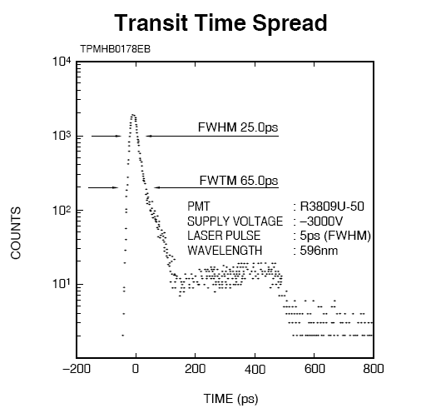
Fig. 5 The transit time spread for a single photo-electron event in Hamamatsu’s MCP PMTs (taken from [10]). We approximate TTS in simulation as a Gaussian random variable with FWHM 25 ps.

At this point in the simulation, we examine the time distribution of signals arriving on the anode to ensure that picosecond resolution is still possible. Three pieces of information were extracted at this stage: the first and average photon detection times and the number of signals detected. In a detector, the first two could be realized by triggering on the leading edge or using a constant fraction trigger, respectively. After using the values provided by Hamamatsu, we determine that RMS average photon time is as small as 1.68 ps. We also predict 50-100 signals detected for each Cherenkov shower.

Fig. 6. The spread in first photon detection times and average photon detections times for a set of 1000 simulations of Hamamatsu’s R3809U-58. Inset is the number of photoelectrons detected for each of these simulations.

In order to estimate the jitter in a signal collected from the back of the anode, we next develop a simulation of the electrical properties of the multianode. After adding another random variable simulating the path length difference based on position, we convert the signal incident on the anode to a current. In making this conversion, we used an MCP gain of 2$´$${\text{10}}^{5}$. These simulated currents were applied to a model of the anode as an electrical circuit using Mentor Graphics’ Accusim [11]. Values of electrical characteristics like capacitance and inductance were assigned according to the physical geometry of the situation.
After obtaining shape and timing information about the pulse output, we determine the jitter of the system according to simulation results. After examining many pulses, we find that the RMS jitter on the leading edge measured at 50% is 0.86 ps. The output pulses from ten simulated pulses are shown as an example in Fig. 7.

Fig. 7. The output voltage from one of four collectors on the back of the anode for ten different simulated showers. The RMS jitter on the leading edge measured at 50% was determined to be 0.86 psec.

Obstacles
While we have shown that this new time-of-flight system is feasible with current technology, many technical challenges remain. The above is all studied in a rather crude simulation, and while it gives hope that a psec TOF system could be built, many obstacles remain. The current suitably fast MCP's are small; 2 in x 2 in MCP's are available, but at present have larger pores and do not have the necessary time resolution. Large and fast MCP's must be developed for this system to be feasible.
Micro-channel plate PMTs will not function well in the large magnetic fields inside of the detector coil. If placed outside of the coil, the system would also detect showers produced in the coil. For particles moving at an angle to the detector, these showers could potentially trigger the time-of-flight system before the original particle does. The magnitude of the problem will be studied with GEANT, but it will certainly be an issue at some level.
If the time-of-flight system is to have picosecond resolution, a system of inexpensive digitization and readout electronics capable of measuring 1 ps must be developed. CDF, for example, would require 40,000 channels.
Finally, this system would require thousands of individual detectors and would be expensive. The construction of a system for the identification of hadrons is not so different from the situation in lepton identification, for which large systems have been built specifically for electron or muon identification and momentum measurement.

Conclusion
We consider a time-of-flight system for detectors at colliders in which micro-channel plate photomultiplier tubes surround the collision vertex. Cherenkov light produced in the MCP PMT windows by the secondary particles is used for detection. If 5 cm by 5 cm devices can be developed with the time resolution of currently available smaller PMT-MCP's, this system could achieve a time resolution of approximately 1 ps, allowing the separation of pions from kaons for momenta up to approximately 20 GeV in a detector such as CDF at the Tevatron.

Acknowledgment
We thank Paul Hink, Bruce Laprade, John Martin, and Wilma Raso, from Burle Industries; and Mario Kasahara, from Hamamatsu Corporation, for their assistance on the properties of MCP PMTs. We also thank Alan Bross and Katsushi Arisaka for useful discussions and guidance. This work was supported by the US National Science Foundation (NSF) Grant PHY-0201792; R. Schroll was also supported by a NSF Graduate Research Fellowship.

References
- D. Toback, P. Wagner, Prospects of a Search for Neutral, Long-lived Particles Using Photon Timing at CDF, (2004).
- CDF-II Collaboration, Nuclear Instruments and Methods 518, 605-608 (2004).
- S. Cabrera, J.P. Fernandez, et al, Nuclear Instruments and Methods 494 416-423 (2002).
- CDF Collaboration, Nuclear Instruments and Methods 461, 579-581 (2001).
- P. Hink, private communications.
- K. Kleinknecht, Detectors for Particle Radiation, 2nd Edition, University Press, Cambridge (1998).
- W. Leo, Techniques for Nuclear and Particle Physics Experiments, Springer-Verlag, New York (1994).
- W. Galbraith, Cherenkov Counters, from W. Galbraith and W. S. C. Williams, eds., High Energy and Nuclear Physics Data Handbook, National Institute for Research in Nuclear Science and Rutherford High Energy Lab, Chilton (1969).
- Hamamatsu Corporation, 2002 Catalog Excerpts : MCP (Microchannel Plate) – PMTs, http://usa.hamamatsu.com/assets/pdf/catsandguides/ PMTCAT_special_mcp-pmt.pdf
- Hamamatsu Corporation, 2002 Catalog Excerpts : Microchannel Plate – Photomultiplier Tube (MCP-PMTs) http://usa.hamamatsu.com/assets/
pdf/parts_R/R3809U-50.pdf
- Mentor Graphics, http://www.mentor.com/accusim

 Manuscript received November 1, 2004. This work was supported in part by US National Science Foundation (NSF) Grant PHY-0201792. T. Credo is at the Illinois Math and Science Academy, Aurora, IL 60506 USA (e-mail: tfcredo@imsa.edu). H. Frisch is at the Physics Department and Enrico Fermi Institute, University of Chicago, Chicago, IL 60637 USA (e-mail: frisch@uchicago.edu). H. Sanders is at the Enrico Fermi Institute, University of Chicago, Chicago, IL 60637 USA (e-mail: harold@frodo.uchicago.edu). R. Schroll is at the Physics Department, University of Chicago, Chicago, IL 60637 USA (e-mail: rschroll@uchicago.edu) F. Tang is at the Enrico Fermi Institute, University of Chicago, Chicago, IL 60637 USA (e-mail: tang@frodo.uchicago.edu).

